Advancements and Innovations: Exploring Emerging Medical Treatments in Fetal Therapy

.
VIRTUAL SYMPOSIUM
  - May 2, 2024

  - SPEAKERS
Dena Matalon, MD | Clinical Associate Professor, Pediatrics - Medical Genetics, Stanford University
Dr. Dena Matalon is a board-certified pediatrician and clinical geneticist with expertise in genomic diagnostics, prenatal genetics, and a wide range of genetically based syndromes and diseases. I trained in a combined pediatrics-genetics residency program at the Children’s Hospital of Philadelphia (CHOP) and am now a Clinical Associate Professor at Stanford University. My clinical and research interests include the impact of genetic variants on development and brain formation, improving the diagnosis of genetic disorders, and limiting bias and unfair discrimination in genetic testing. Currently, I am involved in the Genomics Research to Elucidate the Genetics of Rare disease (GREGoR) Consortium which is a national consortium focused on applying new technologies to discover genetic causes in undiagnosed patients. Additionally, I am leading a study- “Elucidating Genomic Etiologies of Fetal Brain Anomalies”- which aims to use to exome or genome sequencing as a first line genetic test for diagnosis in patients with prenatally detected brain anomalies.

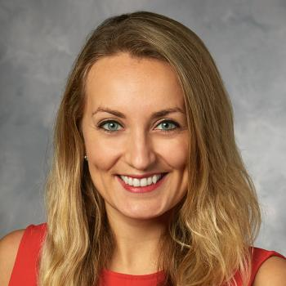
Agnieszka Czechowicz, MD, PhD | Assistant Professor of Pediatrics, Stanford University
Prof. Czechowicz is a translationally oriented-physician scientist at the Stanford University School of Medicine in the Department of Pediatrics, Division of Hematology, Oncology, Stem Cell Transplantation and Regenerative Medicine. She is also a member of the Stanford Institute of Stem Cell Biology and Regenerative Medicine. Dr. Czechowicz previously spent a decade on the Farm as a Stanford trainee completing her undergraduate, medical school and PhD degrees while conducting research with Prof. Irving Weissman. She subsequently did further clinical training in Boston, completing her residency in Pediatrics at Boston Children’s Hospital and pursued subspecialty training in Pediatric Hematology/Oncology at the Dana Farber Cancer Institute while simultaneously conducting postdoctoral research with Prof. Derrick Rossi in collaboration with Prof. David Scadden.

Dr. Czechowicz’s research laboratory focuses on studying hematopoietic stem cells and improving the utilization of these cells for the treatment of diverse blood and immune diseases. She has done pioneering work showing that hematopoietic stem cell depletion is a critical component to donor hematopoietic stem cell engraftment and multiple pre-clinical and clinical therapies are in development based upon her studies aimed at the elimination of chemotherapy and irradiation from transplant protocols. Furthermore, Dr. Czechowicz’s clinical interests are in bone marrow failure syndromes with a particular interest in the inherited cancer predisposition syndrome Fanconi Anemia and she has led several innovative cell and gene therapy trials attempting to improving outcomes for patients with this disease. She was recently recognized for her contributions by the Fanconi Anemia Research Foundation with the prestigious David B. Frohnmayer Early Career Investigator Award. Dr. Czechowicz is also quite passionate about mentoring and training future generations of physicians and scientists and is very supportive of helping diverse trainees on various traditional and non-traditional career paths.
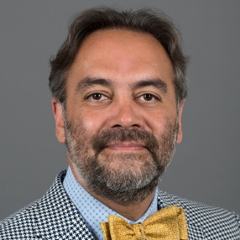
Alireza Shamshirsaz, MD, FACOG| Professor of Surgery, Obstetrics and Gynecology, Chief, Division of Maternal Fetal Medicine and Surgery, Director of Maternal Fetal Care Center (MFCC), Boston Children’s Hospital, Harvard Medical School
Dr. Shamshirsaz currently serves as the Director of the Maternal Fetal Care Center (MFCC) and Chief of Maternal Fetal Medicine and Surgery Division at Boston Children’s Hospital. He has held the position of Professor of Surgery and Obstetrics and Gynecology at Harvard Medical School since 2022. Dr. Shamshirsaz is a Fetal Surgeon and is dual board-certified in obstetrics and gynecology as well as maternal fetal medicine. He also holds the positions of Vice Chair of the SMFM Education Committee, Co-editor in Chief of the Clinical Obstetrics and Gynecology Journal, and Chair of the Steering Committee of the North American Fetal Therapy Network (NAFTNet). Over the course of his professional career in the field of maternal fetal medicine spanning two decades, he has published more than 300 peer-reviewed papers. These primarily focus on complex monochorionic pregnancies, lower urinary tract obstruction, neural tube defects, and placenta accreta spectrum disorders. He has also contributed to and led over 40 systematic reviews and meta-analyses in the field. Additionally, he has spearheaded several international qualitative studies aiming to establish clinical guidelines for controversial topics within the field. In his current role, Dr. Shamshirsaz's research primarily centers on the following three domains: 1) Innovative Fetal Intervention: Dr. Shamshirsaz and his research team are exploring several innovative surgeries for patients with congenital hydrocephalus and vasa previa (FLUMEN study). 2) Innovative Medical Therapies: He has initiated two projects at his current position: one examining the efficacy of Sirolimus in congenital cervicofacial malformations (MaterPons study) and the other assessing the efficacy of Valacyclovir in treating congenital CMV infections. 3) Mesenchymal Stem Cells: His team is investigating the potential of MSCs in treating fetal anomalies.

Carlos E. Milla, MD | Professor of Pediatrics, Stanford University
Carlos Milla is Professor of Pediatrics and (by courtesy) of Medicine at Stanford University School of Medicine, where he is Associate Director for Translational Research at the Center for Excellence in Pulmonary Biology at Stanford. Dr Milla is also the Director of the Stanford Cystic Fibrosis Center and the Stanford CF Translational Therapeutics Development research program. He has actively participated in multiple clinical research studies and has accumulated substantial experience on the diagnosis and development of novel outcomes for pediatric pulmonary disorders. This includes participation in many clinical trials, from early phase to pivotal trials, as well as participating in multiple advisory boards for drug development focused on CF. Dr Milla has published and lectured extensively on the topics of cystic fibrosis and the genetics of rare lung diseases. Current areas of research include early lung disease development and the pathophysiologic mechanisms involved in the defective mucociliary clearance characteristic of CF. Additional research interests include active programs for remote monitoring and biomarker discovery for chronic pulmonary conditions.

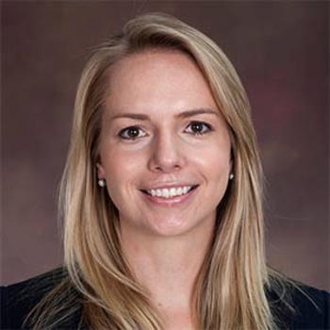
Michelle Kaplinski | Clinical Assistant Professor, Pediatrics – Cardiology
Michelle Kaplinski, MD, MPH, specializes in noninvasive imaging as a pediatric cardiologist and Assistant Professor at Stanford University. She serves as the medical director of the Fetal Cardiology Program and director of the Pediatric Lipid Program at Stanford Children’s Hospital. Her clinical duties include managing fetal and pediatric congenital heart disease patients and attending in the weight and lipid clinic. Her research interests are evaluating and developing strategies to improve outcomes in pediatric hypertension and dyslipidemia and using non-invasive imaging techniques to help diagnose and prognose acquired and congenital heart disease.

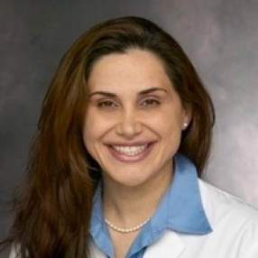
Natali Aziz, MD, MS | Clinical Associate Professor, Obstetrics and Gynecology – Maternal Fetal Medicine, Stanford University
Dr. Natali Aziz is Clinical Associate Professor in the Division of Maternal-Fetal Medicine and Department of Obstetrics and Gynecology at Stanford University School of Medicine. She attended medical school and received her OBGYN residency training at Stanford. She completed Maternal-Fetal Medicine and Reproductive Infectious Diseases fellowships at UCSF.

Dr. Aziz serves as the Director of Perinatal Infectious Disease and Director of Central Valley Perinatal Services for Stanford Children’s Health. As part of her clinical practice, she sees patients in a specialized MFM clinic at Stanford with emphasis on infectious conditions affecting pregnancy. Her perinatal ID interests, in addition to cytomegalovirus, include maternal infections (HIV, HBV, syphilis, etc.), maternal immunization, and management of peripartum infections, as well as obstetric care pertaining to pregnant women during the COVID-19 pandemic.

